**5.2 Exercises: Charts**

Alexa L. Wittlieff

College of Science and Technology, Bellevue University

DSC640-T301 Data Presentation & Visualization (2227-1)

Dr. Catie Williams

August 13, 2022

**Power BI – Histogram**

**Power BI – Box Plot**

**Power BI – Bullet Chart**

**Power BI – Scatter Plot**

**Python – Histogram**

**Python – Box Plot**

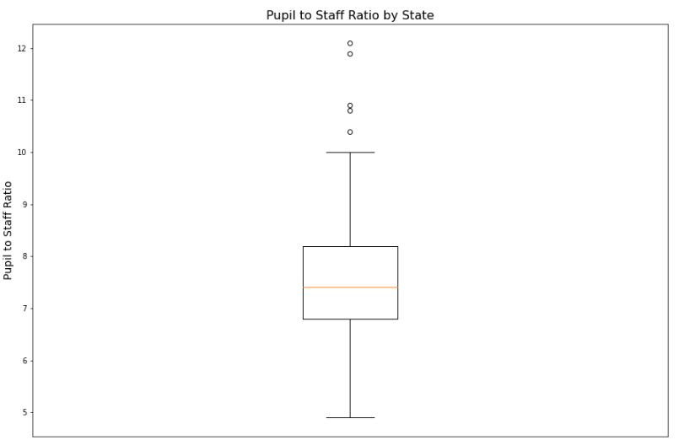

**Python – Bullet Chart**

**b**

**Python – Scatter Plot**

**R Studio – Histogram**

**R Studio – Box Plot**

**R-Studio – Bullet Chart**

**R-Studio – Scatter Plot**

